

**REPORT OF PROJECT ON E-COMMERCE WEBSITE OF**

**FRUITS AND VEGETABLES**

AS A PROJECT WORK FOR THE COURSE

**INTERNET PROGRAMMING (CSE 326)**

**NAME: SANJO JOHNY SUBMITTED TO:** MS. DIVYA THAKUR

**REGISTRATION NUMBER:** 12206357  **DATE OF SUBMISSION:** 01/12/2022

**ROLL NUMBER:** 64

**SEMESTER:** FIRST SEMESTER

**SCHOOL OF COMPUTER SCIENCE AND ENGINEERING**

**LOVELY PROFESSIONAL UNIVERSITY, JALANDHAR, PUNJAB,**

**INDIA.**

**DECLARATION**

I Sanjo johny hereby Registration No. 12206357 declare that the project work reported entitled "E-commerce website of fruits and vegetables” in partial fulfilment of the requirement for the award of Degree for Bachelors of Technology in CSE at Lovely Professional University, Phagwara, Punjab is an authentic work carried out under supervision of my supervisor Ms. Divya Thakur. The content of this project represents authentic and honest effort conducted, in its entirety, by me. I am fully responsible for the contents of my project work.

Student Name: Sanjo johny Student Signature:



Registration Number: 12206357

**INDEX**

**Content Page No.**

Introduction 4

Project details 5

Code 6-8

Results 9

**HTML, CSS AND JAVASCRIPT**

**INTRODUCTION**

Internet/web programming refers to the writing, markup and coding involved in Web development, which includes Web content, Web client and server scripting and network security. The mostcommon languages used for Web programming are XML, HTML, JavaScript, Perl 5 and PHP.

**HTML:**

HTML stands for Hyper Text Markup Language.

HTML is the standard markup language for creating Web pages.

HTML describes the structure of a Web page.

HTML consists of a series of elements.

HTML elements tell the browser how to display the content.

HTML elements label pieces of content such as “this is a heading”, “this is a paragraph”, “this is a link”,etc.

**CSS:**

CSS stands for Cascading Style Sheets.

CSS describes how HTML elements are to be displayed on screen, paper, or in other media.

CSS saves a lot of work. It can control the layout of multiple web pages all at once.

External stylesheets are stored in CSS files.

**JAVASCRIPT:**

JavaScript is a cross-platform, object-oriented scripting language used to make webpages interactive (e.g., having complex animations, clickable buttons, popup menus, etc.). There are also more advanced server side versions of JavaScript such as Node.js, which allow you to add more functionality to a website than downloading files (such as real time collaboration between multiple computers).

JavaScript contains a standard library of objects, such as Array, Date, and Math, and a core set of language elements such as operators, control structures, and statements.

**PROJECT**

This project as titled “e-commerce website of fruits and vegetables” is programmed with help of HTML, CSS and JAVASCRIPT. It contains home page, product page, explore page, account page and cart page. Home page have many navigation icons to navigate on other pages, it includes featured product, exclusive product, review and footer. Product page contains two different web page as fruits and vegetables, it contains many fruits and vegetables ion form of a table. We can navigate to any page to other page just by clicking on particular icons. Explore page contains a lot of YouTube videos linked with the help of iframe like benefits of fruits and vegetables, recipes of different dishes and some other things. Then account page have login and register options. Finally cart page is designed to show the total type and amount of products selected along with the total price, it also gives option of final order and cancelling the order. Along with the top of webpage in many pages we can go to different pages by clicking on the button given at the bottom with specifying the page to which it will lead.

**CODE**

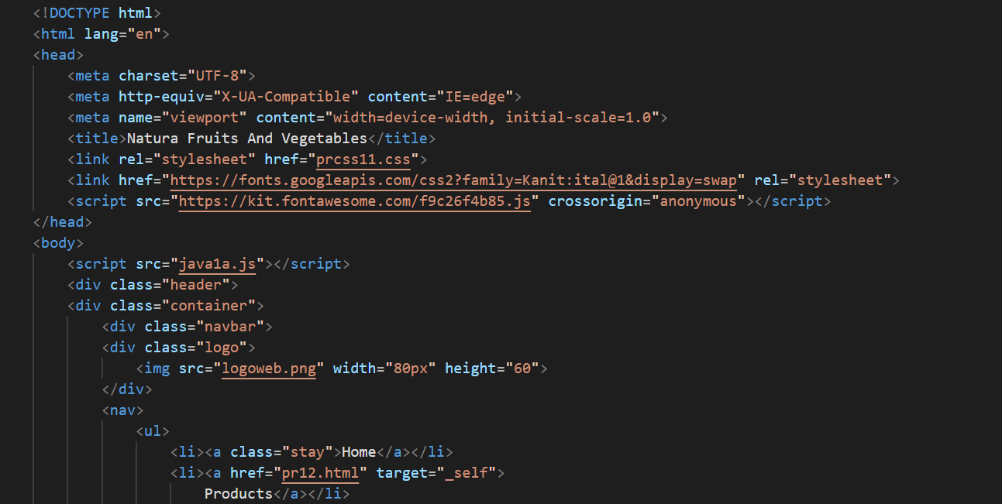 HTML CODE (Home Page):

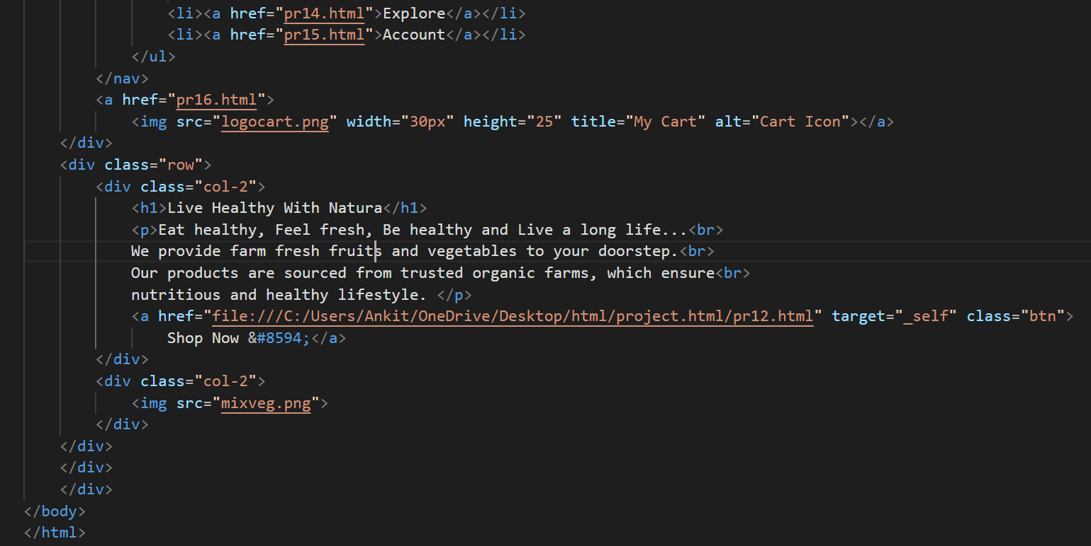

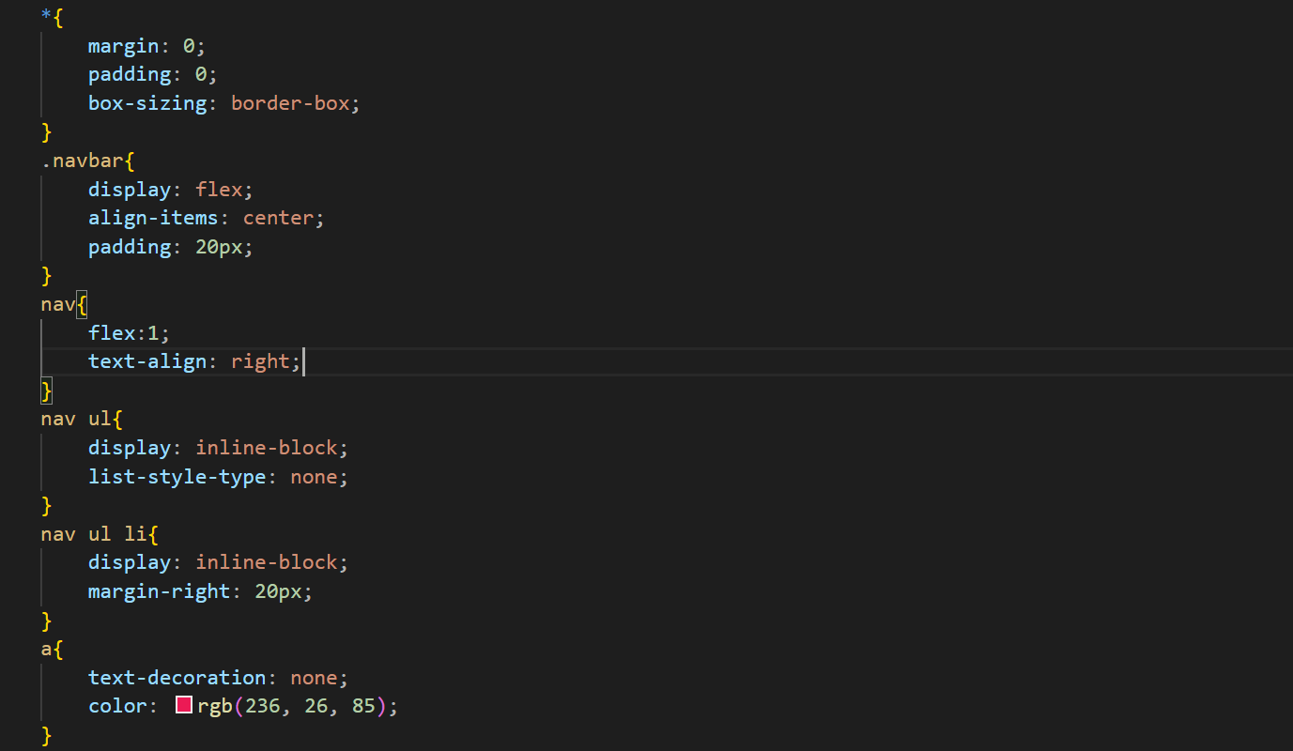 CSS CODE (Home Page):

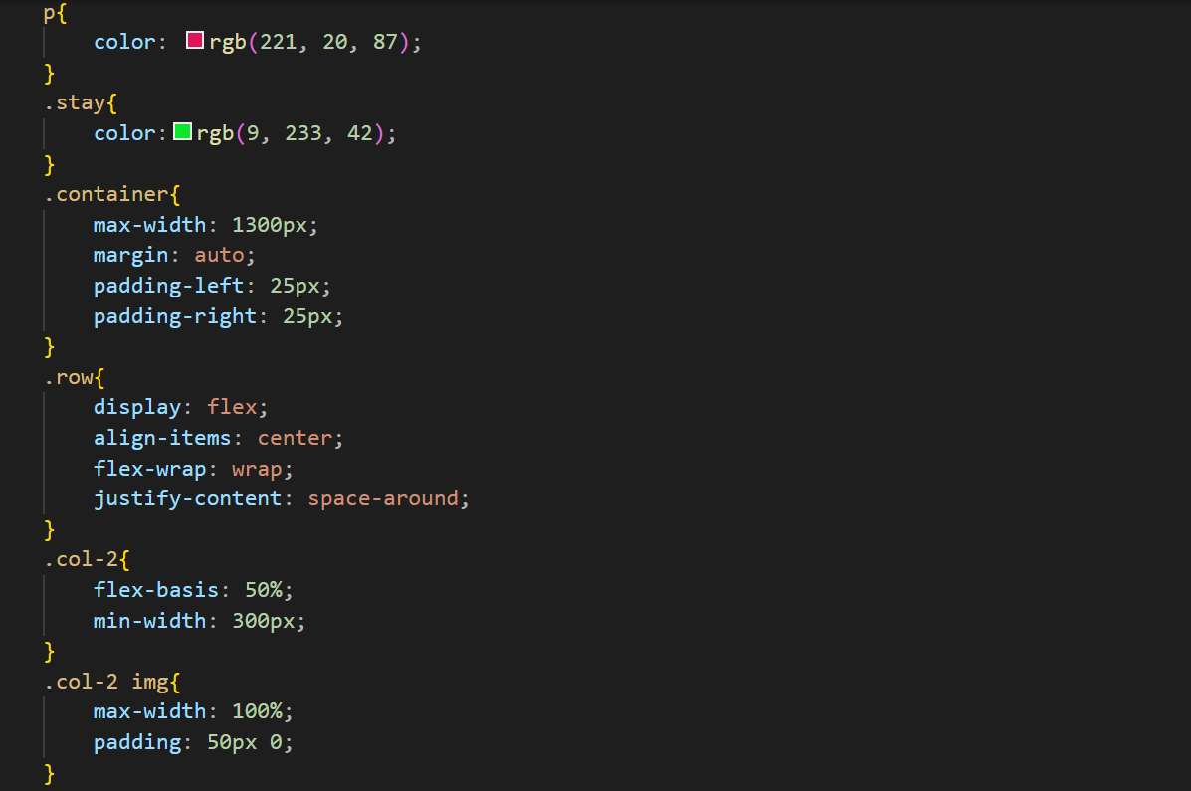

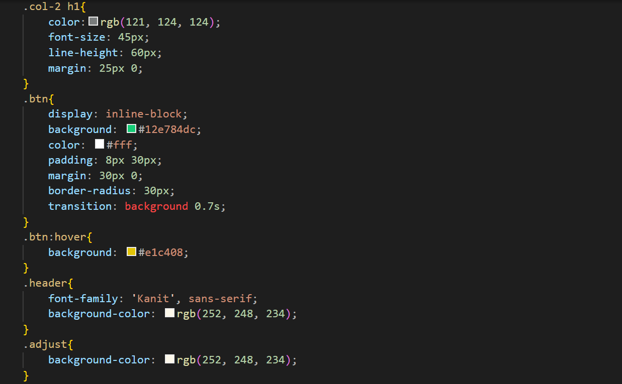

JAVASCRIPT CODE (Home Page):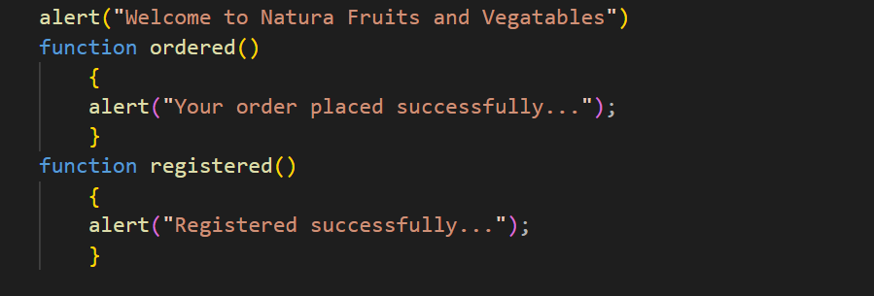

**RESULTS**

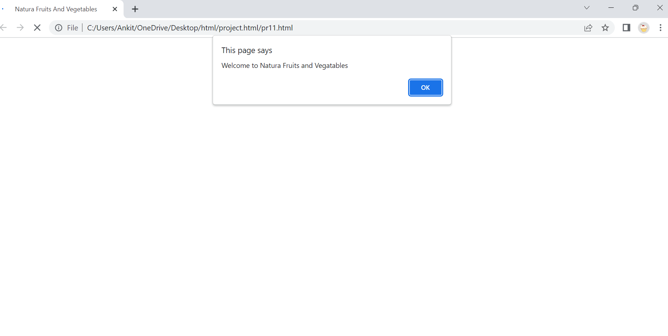Result of alert displaying welcome message:

Result (Home Page):

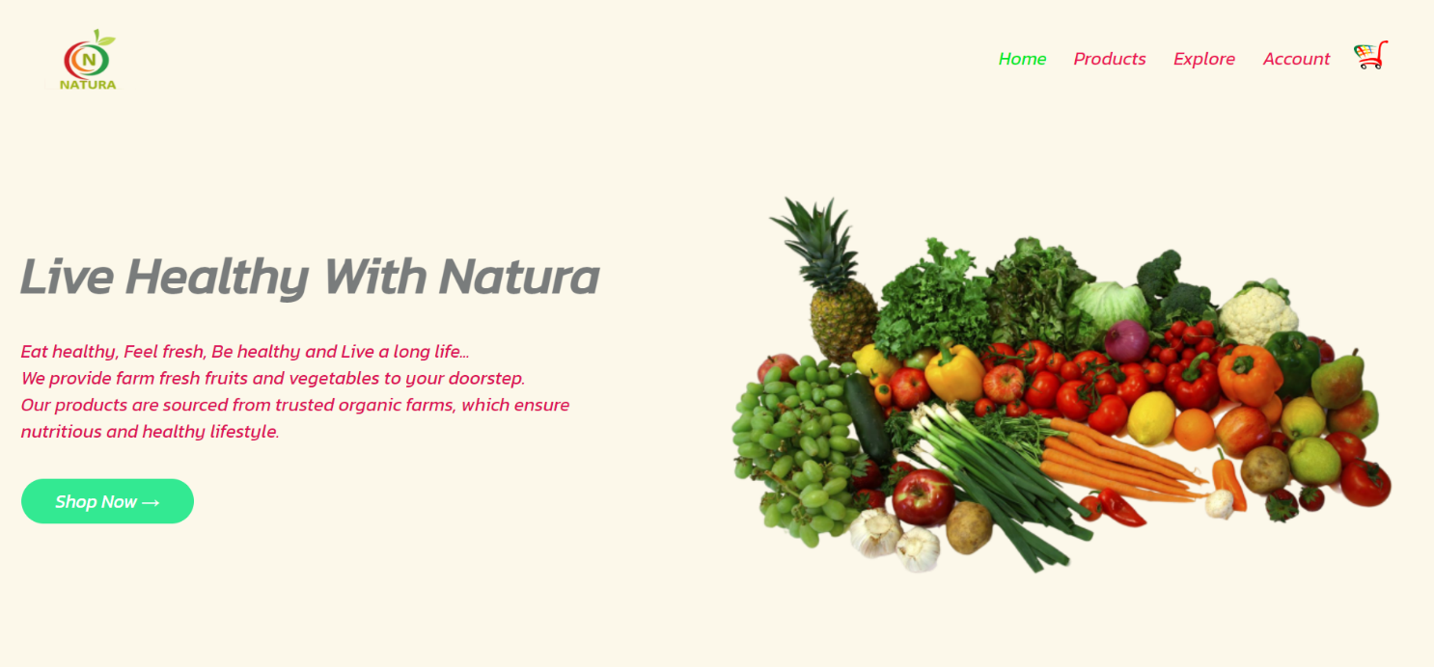

**\*\*\*\*\*\*\*\*\*\*\*\*\*\*** End Of Project Report **\*\*\*\*\*\*\*\*\*\*\*\*\*\***

**Thank You**